Lab 1

### Node architecture and memory



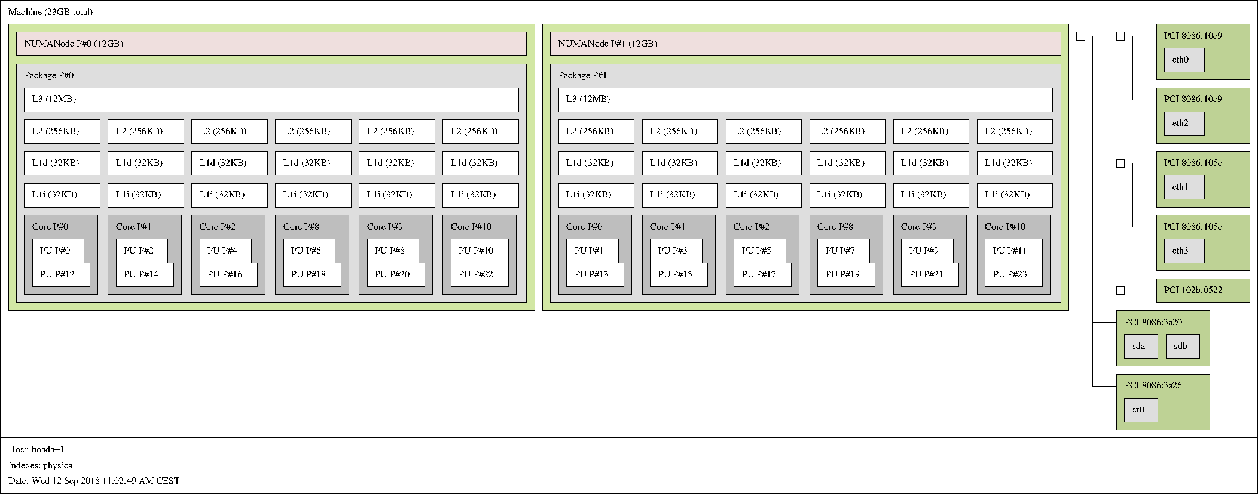

### Strong vs. weak scalability

String scalability: Increase the number of processors with constant problem size.

Weak scalability: Increase the number of processors with problem size proportional to numbr of processors.

Weak:

Speed Up Time

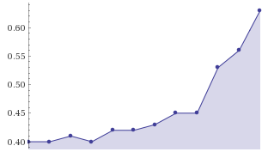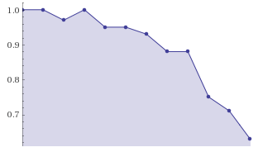

Strong:

Speed Up Time

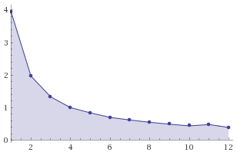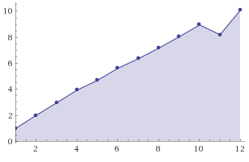

Weak method: Work increase with the number of threads, then, time, ideally, should be the same with any number of cores but with more curated result as more cores are we using.

Strong method: time decrease with the number of threads, then, time, ideally, should decrease by 1/#threats. But it is not perfect.

Both versions have strong scalability, decreasing time as more cpus are added. We can see that V5 is able to scale better, that is due to the following changes made in V4:

Parelization applied in all J and K loops. For exemple:

void transpose_xy_planes(fftwf_complex tmp_fftw[][N][N], fftwf_complex in_fftw[][N][N]) {

int k,j,i;

**for** (k=0; k<N; k++) {

tareador_start_task(**"transpose_xy_planes K loop"**);

**for** (j=0; j<N; j++) {

tareador_start_task(**"transpose_xy_planes J loop"**);

**for** (i=0; i<N; i++)

{

tmp_fftw[k][i][j][0] = in_fftw[k][j][i][0];

tmp_fftw[k][i][j][1] = in_fftw[k][j][i][1];

}

tareador_end_task(**"transpose_xy_planes J loop"**);

}

tareador_end_task(**"transpose_xy_planes K loop"**);

}

}

In addition, V5 can use 128 cores, using about 6ns of CPU time. This is explained with the task dependence images of V4 and V5, where we can observe the difference in the number of parallelizable tasks.

|  |  |  |  |  |  |
| --- | --- | --- | --- | --- | --- |
| Version | φ | S∞ | T1 | T8 | S8 |
| Initial | 0,283940 | 1,43 | 2,07 | 1,43 | 1,45 |
| Improved φ | 0,82 | 1,09 | 2,4 | 1,09 | 2,20 |
| improved parallel overheads | 0,79 | 1,37 | 2,75 | 1,37 | 2 |
| improved work–distribution overheads | --- | --- | --- | --- | --- |

Paraver cannot handle the size of the traces.

